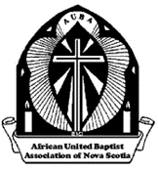
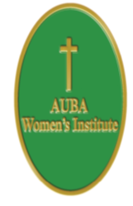
African United Baptist Association of Nova Scotia
WOMEN’S INSTITUTE
Pre-Registration Form
67th Annual Sessions
October 15, 2022
Hosted by:
New Horizons Baptist Church

Name: ____________________________________________

Address: __________________________________________
Email:_____________________________________________
Church: ___________________________________________

Check off (Group Name)
- Ladies Auxiliary
- WMS
- Other

Registration: (please mark with an X). All is 25.00

Delegate Member Visitor

Meals: (please mark with an X) Sat. Lunch $20.00

Deadline to Pre-Register is September 30, 2022
Food Allergies - Please indicate any food allergies: _________________________________________
Registration Fee:
$

Saturday LUNCH
$

Total
$

Make cheque or money order payable to: AUBA Women’s Institute (DO NOT SEND CASH) and send to: Mrs. Lillian Cain, (Treasurer) 1024 Montague Road, Montague Gold Mines, NS B2R 1T8
African United Baptist Association of Nova Scotia
WOMEN’S INSTITUTE
Pre-Registration Form
67th Annual Sessions
October 15, 2022
Hosted by:
New Horizons Baptist Church

Name: ________________________________________________________

Address: _____________________________________________________
Email:________________________________________________________
Church: ______________________________________________________

Check off (Group Name)
- Ladies Auxiliary
- WMS
- Other

Registration: (please mark with an X). All is 25.00

Delegate Member Visitor

Meals: (please mark with an X) Sat. Lunch $20.00

Deadline to Pre-Register is September 30, 2022
Food Allergies - Please indicate any food allergies: _________________________________________
Registration Fee:
$

Saturday LUNCH
$

Total
$

Make cheque or money order payable to: AUBA Women’s Institute (DO NOT SEND CASH) and send to: Mrs. Lillian Cain, (Treasurer) 1024 Montague Road, Montague Gold Mines, NS B2R 1T8

