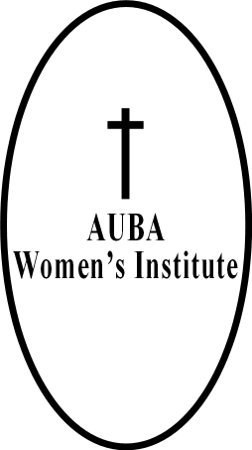
African United Baptist Association – Women’s Institute
Mail: 412-36 Kelly Street
Halifax, NS B3N 1W2

Secretary: Sis. Monica Skinner
E-mail: skinner2007splash@gmail.com
Phone: 902-444 5691
July 16, 2022

Greetings,

  - On behalf of the African United Baptist Association – Women’s Institute, we would like to inform your church about the 67th annual sessions. The sessions will be held on Saturday, October 15th, 2022. Hosted by New Horizons Baptist Church ladies. Their church is being renovated at this time that is why the sessions will be held at Faith City Church (6225 Summit Street, Halifax). More information will be made available later. We pray that your congregation will be able to attend this year. As we know we are still dealing with the pandemic. Know that we are praying for each ladies group of the church. Here is brief outline of the session:
Registration begins at 9:00 am.
Praise Time: 9:30 am – 10:00 am
Opening session: 10:00 am
Business session: 10:45 am – 11:45 am
Lunch: 12:00 pm – 1:00 pm
Afternoon session (unfinished business): 1:00 pm – 1:15 pm
Workshop(s): 1:15 pm – 2:45 pm
Praise Time: 2:45 pm – 3:00 pm
Worship Service: 3:00 pm

Theme: “Her Children Rise Up And Call Her Blessed”
Theme Hymn: “We’re Blessed”
Text: Proverbs 31:28

  - Please find attached is the African United Baptist Association – Women’s Institute applications for the Gertrude E. Smith Scholarship and Trust Fund. This funding help students financially. If your church has any questions about the upcoming African United Baptist Association – Women’s Institute sessions, you can reach me at 902 444-5691.

Thank you,
Monica Skinner
Sis. Monica Skinner
Secretary

Deacon Catherine Hartling
President

Sis. Althea Tolliver
1st Vice President
Retreat Committee

Sis. Monica Skinner
Secretary

Sis. Bernadine Sparks
Assistant Secretary

Sis. Lillian Cain
Treasurer

Sis. Laura Francis
Assistant Treasurer

Dr. Carolyn G. Thomas
Gertrude E. Smith Scholarship
Workshop Committee

Sis. Linda Williams
Trust Fund

Sis. Germaine Howe
Membership Convener

Sis. Leslie Daye
Sis. Johanna Cromwell
Hospital Visitors

Sis. Marian Colley
District #1 Representative

Sis. Regena David
District #2 Representative

Pastor Theresa Character
District #3 Representative

Pastor Clara Jordan
District #4 Representative

Sis. Alexis Smith
Organist

