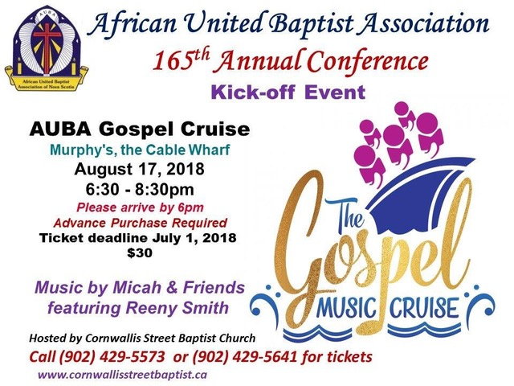

**AFRICAN UNITED BAPTIST ASSOCIATION**

**WOMEN’S INSTITUTE**

**GERTRUDE E. SMITH SCHOLARSHIP COMMITTEE**

Dr. Carolyn G. Thomas

2032 Highway #7

East Preston, NS

B2Z 1G1

Dear Pastor and Clerk:

Enclosed you will find application forms for the Gertrude E. Smith Scholarship Fund. Would you please post copies on the church bulletin board and promote scholarship in the weekly church bulletin.

In doing this, hopefully, female members of your congregation will become aware of the scholarship and will apply for the funding.

Thanking you in advance for your assistance.

Sincerely,

Dr. Carolyn G. Thomas

Scholarship Chairperson



African United Baptist Association of Nova Scotia

**Women: Institute**

Application Form

for

**Gertrude E. Smith Scholarship**

**Deadline for Application – July 31st**

No application will be processed after the above mentioned date

(Please Print Clearly or Type)

**Personal History:**

Name in full:

Address: _____________________________________________________________________________________

__________________________________________ Postal Code _______________________________

Telephone: ________________________________ Date of Birth: _______________________________

Have you been a resident in Nova Scotia for the past 5 years: ( ) Yes ( ) No

Parent(s)/Guardian(s): _________________________________________________________________

Are you a Member ( ) or Adherent ( ) of a Church within the African United Baptist Association of Nova Scotia? ( ) Yes ( ) No

Name of Church: _______________________________________________________________________

Name of Pastor: _______________________________________________________________________

Educational Goal: ______________________________________________________________________

**Financial Information:**

Estimated yearly expenses: ______________________________________________________________

* Amount you expect to be able to contribute: _______________________________________
* Amount expected from other sources: ___________________________________________

Did you receive a scholarship or bursary from the Women’s Institute last year? ( ) Yes ( ) No

Name any other organization(s), etc. approached for assistance: _________________________________

_____________________________________________________________________________________

**University Registration:**

Name, Address and Telephone Number of the educational facility you will be attending:

Name of University/College: ______________________________________________________________

Address: ______________________________________________________________________________

Postal Code: ________________________ Telephone Number: _________________________________

Student Identification Number (ID): ________________________________________________________

Name of degree program/course: _________________________________________________________

_____________________________________________________________________________________

Number of years required to complete the program: __________________________________________

What year of study will you be entering: (Please circle): **1 2 3 4**

**THE FOLLOWING MUST ACCOMPANY YOUR APPLICATION – Please check off to ensure you have included the following:**

( ) Assigned Student ID Number

( ) Copy of Transcript of Marks for last term of last year of study

( ) Acceptance Letter from University/College and Confirmation of Enrollment

( ) Letter of Reference from Pastor, Deacon, or President of Women’s Group

Applicant’s signature: ___________________________________________________________________

Date: ________________________________________________________________________________

**Please mail to:**

Dr. Carolyn G. Thomas

Scholarship Chairperson

2032 Highway #7

East Preston, NS

B2Z 1G1