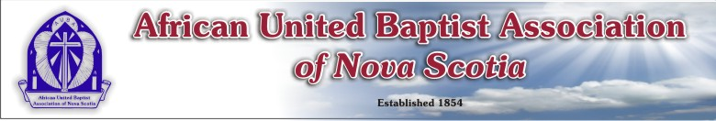
Suggested Accommodations:
- Best Western Plus Dartmouth Hotel & Suites
15 Spectacle Lake Drive
Dartmouth, NS

Phone: 902-463-2000

- Holiday Inn Express and Suites /Dartmouth Crossing
335 John Savage Avenue
Dartmouth, NS

Phone: 902-431-1122

- Hampton Inn & Suites (Dartmouth Crossing)
65 Cromarty Drive
Dartmouth, NS

Phone: 902-406-7700

- Marriott Residence Inn / Dartmouth Crossing
35 Shubie Drive
Dartmouth, NS

Phone:902-406-4000

- Delta Hotel / Burnside
240 Brownlow Ave.
Dartmouth, NS

Phone: 902-468-8888

- Doubleteee by Hilton
101 Wyse Road
Dartmouth, NS

Phone: 902-463-1100

The venue for the 169th Annual Session is centrally located; therefore, the selection of restaurants is beyond listing.

