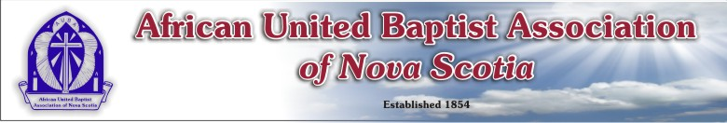

AFRICAN UNITED BAPTIST ASSOCIATION OF NOVA SCOTIA
Registration Form (169th Annual Sessions)
August 19 – 21, 2022
Venue – Saint Thomas Baptist Church, North Preston, NS
THEME: “SUBMITTED IN SPIRIT”- (Acts 2:36-41)

Name: ________________________________________________________________________
Address: ________________________________________________________________________
________________________________________________________________________
Church/Group: ________________________________________________________________________
Registration (Please indicate with an X)
___________ Delegate ___________ Member ____________ Visitor
$45 by July 15th $30 by July 15th $30
$50 after July 15th $35 after July 15th

PLEASE NOTE: MEALS ARE AVAILALE AT THE NORTH PRESTON RECREATION CENTRE
Lunch on Saturday, August 20, 2022 – FREE OF CHARGE
Supper on Saturday, August 20, 2022 - $15.00
Lunch on Sunday, August 21, 2022 - $15.00

Registration Fee $_____________
Saturday Supper $_____________
Sunday Lunch $_____________
Total $_____________

Please send form and payment (cheque or money order) to:
Payable to AUBA
c/o Adam Cain (AUBA Treasurer)
10 Cherry Brook Road, 1st Floor Black Cultural Centre
Cherry Brook, Nova Scotia / B2Z 1A8

E-transfers for the AUBA can be sent to info@aubans.ca

